The Twilight of Military Keynesianism: Russia and Ukraine.

Russia invaded Ukraine on the 24th of February, 2022. On the 9th of May 2022, [the Telegraph](https://www.telegraph.co.uk/business/2022/05/09/ftse-100-markets-live-news-russia-energy-mccolls/) reported that the Russian finance ministry was, following Western sanctions, anticipating a 12% fall in GDP – the biggest since 1994. On the 8th of June, 2022 [Reuters reported](https://www.reuters.com/markets/europe/russias-economic-slump-will-wipe-out-15-years-gains-iif-2022-06-08/) that the Institute of International Finance forecast a 15% shrink that year and a 3% reduction next year; indeed, the batch of Western sanctions had apparently triggered the ‘full disintegration of 30 years of investment’.

In hindsight, it is easy to poke fun at the alarmist Western economists who always get it wrong. Less mentioned are the Russian economists who made the same mistake. Nevertheless, these attitudes are rarely surprising. Economics is the [dismal science](https://intothepeasoup.substack.com/p/by-any-means-necessary), after all. Realists, on average, outperform pessimists. The Russian economy did shrink in 2022 – but only by around 2%. In 2023 and 2024, we’ve seen above-average output growth (see chart).

*Source: International Monetary Fund. Own Illustration. Quarterly data seasonally adjusted using 4-quarter moving averages.*

It is natural that such a stark difference between forecasted and actual rates has not only diminished the credibility of Western economic institutions (the Russian ones never had much to begin with), but also fanned the flames of what has come to be termed Military Keynesianism (MK).

For the uninitiated, John Maynard Keynes is the pre-eminent economist of the early twentieth century. He first rose to prominence after writing *The Economic Consequences of the Peace*, a scathing polemic against the Big Three – Wilson, Clemenceau, and Lloyd George – after they brokered the Treaty of Versailles following WWI. Keynes’ later *General Theory* fundamentally changed the economics discipline and arguably invented modern macroeconomics.

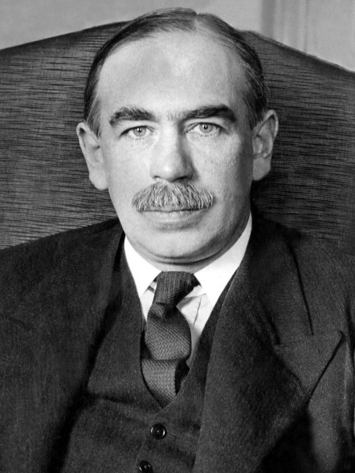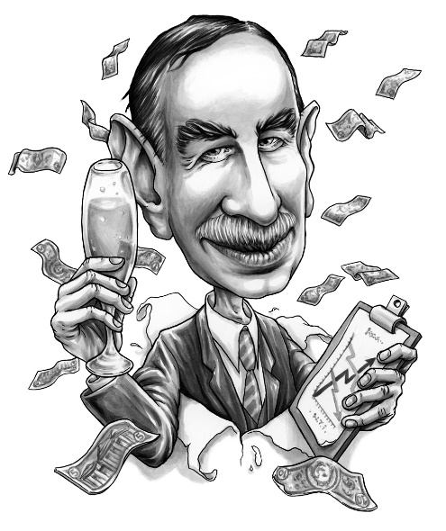

*Left – J.M. Keynes; Right – J.M. Keynes as a cartoon*

The crux of classical Keynesian economic theory lies in the idea that the general level of demand in an economy can increase without accelerating inflation. Keynes theorised that following recessionary periods (for example), low levels of demand in an economy may effectively become ‘baked in’ – unemployment of labour and capital entrenches itself because entrepreneurs don’t believe that the extra goods produced by hiring workers or leasing machinery will cover the cost of doing so. If demand could increase somehow, entrepreneurs would find that there does now exist a market for these potential goods and so they would begin investing again – with more money now being spent, by both firms and new workers, this higher level of employment can sustain itself even if the initial boost to demand dissipates. Keynes argued that the government should take on the role of stimulating this initial surge in demand by spending on *anything*. Of course, productive investments, like public works projects, should be the priority, but he famously wrote that even if the government hired the [unemployed to dig holes in the ground, this would still be beneficial](https://econ.economicshelp.org/2008/07/john-maynard-keynes-great-economists.html#:~:text=%22The%20government%20should%20pay%20people,and%20then%20fill%20them%20up.%22&text=Keynes%20would%20respond%20saying%20%22Fine,of%20intervening%20in%20a%20recession.).

Inflation is understood to increase when aggregate spending rises while the real output of a nation, in terms of the *quantity* of goods and services, does not increase. Keynes’ theory postulates that a rise in spending can precipitate a rise in output, so government spending in these cases